Corrected Liquid crystals 20-03-2020

Q- What /define are liquid crystals? Explain molecular ordering positional and orientational order in solid, liquid and liquid crystals. Mention general applications of liquid crystals.

Definition: Liquid crystals (LCS) may be defined as the distinct state of matter, in which the degrees of molecular ordering (positional and orientation order) is lies between ordered anisotropic crystalline state and completely disordered isotropic liquid state.
The terms mesophase and mesogen also refer to the liquid crystal state. Liquid crystals exhibit optical anisotropy, i.e., they possess different optical properties when light is incident in different directions. Liquids, however, exhibit optical isotropy i.e., they exhibit the same optical property irrespective of the direction of the incident light. All LCS are organic molecules with rod or disk shape.

Positional and orientational order in solids, liquids and liquid crystals :
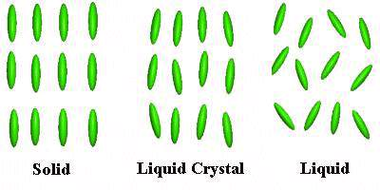

Figure 1: Positional and orientational order in solids, liquids and liquid crystals
In solid crystal state, the molecules are highly ordered. Each molecule occupies a definite position in a more or less rigid arrangement and in immobile rigid arrangement and orient in a preferred direction.
In liquid state, the molecules neither occupy specific positions nor remain oriented in a particular manner. The molecules are overcome with cohesive forces of attraction and are somewhat free to move at random colliding with one another and change their position abruptly.
Intermediate state between the solid state and the liquid state exists another metastable state is called Liquid crystalline phase, wherein the molecules are free to move but are oriented in a particular manner.
For example: Solid cholesteryl benzoate (CB) on heating becomes hazy liquid, which on further heating turns into a clear and transparent liquid. On cooling these changes were observed exactly at the same temperature. Between 145 ºC and 179 ºC the temperature at which it converts into the liquid crystalline state is called phase transition temperature. The temperature at which the transition from liquid crystalline state to isotropic liquid (179 ºC) state is called clearing temperature.
The structure of cholesteryl benzoate is given below.

Figure 2: Structure of cholestryl benzoate
General applications of liquid crystals: liquid crystal find application in areas of science and engineering, particularly in display systems. Devices using liquid crystalline displays (LCD) have the advantages of low power consumption at lesser cost and hence widely used in electro-optic displays like mobile communication, high-resolution T.V displays, calculator, aircraft cockpit etc. Liquid crystal also finds application in temperature sensors, thermography, pressure senor etc.

Q- What is Director? Explain its significance.

Director and its significance: In a liquid crystal the molecule passes orientational order i.e. the molecule tends to remain a particular direction. The direction of preferred orientation of molecules in a liquid crystalline phase is called a director. Since molecules are in constant motion and they spend more time pointing along the director than any other direction. Hence the extent of orientational order can be described by taking an average angle ϴ made by different molecules with the director.
Director
0⁰
Director
θ⁰

Solid state Liquid crystalline state

Figure 3 : Director in solid state and liquid crystalline state

Significance of director :
- An average angle of 0⁰ indicates perfect orientation and can expected in solid crystals.
- Liquid crystals exhibit a smaller average angle (0 -5⁰) with the director.
- An average angle greater than 45⁰ indicates no orientational order as found in liquids.

Q- Discuss the classification of liquid crystals with suitable example

Or Explain the molecular ordering in Thermatropic and Lyitropis liquid crystals.

Classification of Liquid crystals: Liquid crystals are classified into two main categories namely
- Thermotropic
- Lyotropic
(i)Thermotropic liquid crystals: The class of compounds that exhibits crystalline behavior or variation of temperature alone is called thermotropic Lcs. More no. of thermotropic Lcs are formed from organic molecules with a rod like shape.
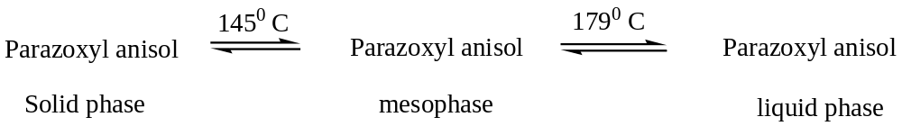
Thermotropic liquid crystals are obtained by raising the temperature of solid and by lowering the temperature of the liquid. Thermotropic LCS are further classified into 3 phases
- Nematic
- Smectic
- Cholesteric (chiral or twisted)
- Nematic mesophase: The liquid crystalline phase is made up of optically inactive rod - like molecules. In this phase, the molecules have no layered structure. The molecules in nematic phase possess intermolecular forces such that they are parallel to one another and hence nematic phases are characterized by the total loss of positional order and their behavior is very close to their anisotropic liquid phase. When the nematic phase is observed in polarized light the molecule appears to have thread like texture.
Example: P-azoxy anisole (PAA) which is stable between 118 -135 ⁰C
Applications: Nematic phase liquid crystals are widely used for displays. This is based on change
of plane polarization during the application off the electric field.
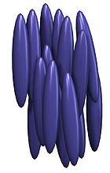

Figure 4: Nematic liquid crystal
- Smectic mesophase: Smectic phased molecules are cigar-shaped molecule and are arranged in layers. In this mesophase, the molecules possess a small amount of positional order and orientational order. The molecules tend to point along the direction and can move forward and backward but not up and down i.e. 2- dimensional motion can be possible. Based on the orientation of the director there are 9 types of smectic phases identified [smectic A to I]
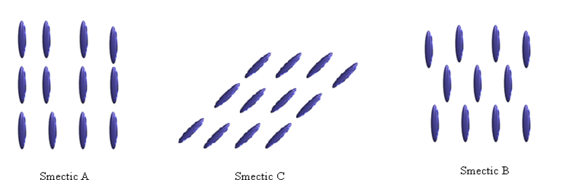

Figure 5: Smectic mesophase
Example: 4-n-butyloxy benzylideneamino-propiophenone (Smectic C)
4,4’-di-heptyloxyazoxybenzene. (Smectic C)

iii. Cholesteric or chiral or twisted mesophase: They are formed from optically active compounds having chiral (twisted) centers. In this mesophase, all the molecules stay parallel to one another and arrange themselves at different angles with respect to their adjacent groups. In this mesophase the director rotates throughout the sample forming a helical pattern as it changes just like a nut screwed on a bolt. The distance covered by a director as it completes one full turn (360º) is called the ‘pitch’ of the liquid crystal. The pitch repeats throughout the substance.
The pitch length of a cholesteric varies sensitively with temperature, pressure, impurities, electric field The most striking feature of cholesteric mesophase is strong optical activity and selective reflection, which are attributed to the twisted structure.
The twist present in these mesophases makes them to exhibit spectacular optical properties, which are made use of in displays. A cholesteric Liquid Crystals rotates the direction of linearly polarized light. The pitch length is temperature dependent and hence cholesteric liquid crystals are used in thermography.
Example: cholesteryl benzoate, cholesteryl formate

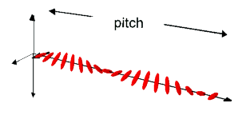
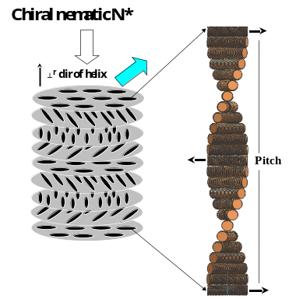
Figure 6: Cholesteric or chiral or twisted mesophase
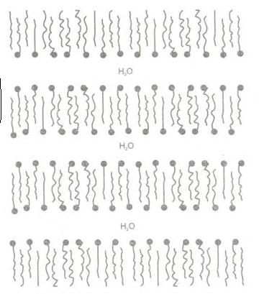
(ii) Lyotropic liquid crystals: Liquid crystals that are obtained by mixing the two components - organic solids compound (amphiphilic) and polar solvent. Increasing the concentration of the one of the components till liquid phase is obtained such liquid

Figure 7: Lyotropic mesophase
crystals are called lyotropic liquid crystals.The amphiphilic or amphiphile compound possesses two groups that differ greatly in their solubility properties. One part of the molecule has ‘hydrophilic head’ which is highly soluable in H₂O. While other part has hydrophobic or lyophobic tail which is highly soluble in hydrocarbon solvents.
In the lyotropic phase, the water is sandwiched between the polar heads of adjacent layers of amphiphilic molecules. Example:
- Soap water mixture
- DNA
- Synthetic polypeptides
- Biological compounds such as proteins, nucleic acid, also exhibit lyotropic type of liquid crystalline behaviour in water.

Q- What are the requirements for an organic molecule to exhibit Liquid crystalline behaviour ?

The requirements of a molecule to form liquid crystal are:
- the molecules should be elongated in shape and
- appreciable part of the molecule should have rigidity with preferably flexible ends. In some liquid crystals the central part of the molecule is rigid with flexible ends (See Figure below).
- in some others, rigid segments are attached along its length by short flexible segments as in polymers. The flexible part twists its way throughout the substance causing the molecules to lose its positional order.
Rigid segments
Rigid segments

Figure 8. Orientational order in liquid crystals – illustration of how rigid segments help in maintaining orientational order in (a) molecules with rigid central part and flexible ends (b) chains where rigid groups are attached through flexible segments and (c) flexible chains with side chains carrying rigid segments

But, the rigid segments in the molecule attempts to maintain the orientational order typical of liquid crystals. In addition, elongated molecules have strong attractive forces when they are aligned parallel to one another. The collision of the molecules with one another is less and all of them tend to point in one direction and thus the mesophase is stabilized. The flexibility of the ends allows a molecule to position itself more easily between other molecules when they move about.

Q- Explain the basic structure of liquid crystals.
For many liquid crystals, their chemical structure can be represented as follows:

Bridging group

Rigid core Terminal group

Sustituent group

Ex:

H₃CO N = N OCH₃
↓
O
p- azoxyanisole

In the structure, R is called substituent group, A & B are aromatic groups/rings. Z is linking group and X is terminal group.
Side Chain [R] (Substituent group): Three commonly used side chains are: (i) Alkyl group
(ii) Alkoxy group (iii) Alkynyl group (iv) alkynyl oxy group
The length (the number of carbon atoms) and flexibility of the substituent group affect the phase transition and type of mesogenic phase. When the number of carbon atoms in the side chain is less (3-5, lower order) show the nematic phase. When the number of carbon atoms in side chain is more (9-12, higher - order) shows only smectic phase. When the number of carbon atoms in side chain is more (6-8, middle - order) show nematic and smectic phases.

Linking group or bridging group: it contributes to the phase transition temperatures and physical properties of liquid crystalline phase. Several linking groups have been used:
Aromatic rings [A & B]: most of the compounds exhibiting liquid cryatalline phase, consists of one or more aromatic rings. These aromatic rings may be phenyl, biphenyl, terphenyl or a combination of the above rings.
Usualy longer the rigid core, the higher is the transition temperatures.
Terminal group (X) : Several terminal groups have been used like Alkyl group, Alkoxy group, Alkynyl group, Alkynyl oxy group, halogens,, Nitro (-NO), amino, sulphide cyano (CN) etc

Q- What is homologous series? Explain liquid crystalline behavior in homologous PAA and MBBA homologous series?
A series of compounds of the same type wherein successive members differ in their molecular formula by CH₂ group is called homologous series. The composition of any homologous series can be expressed by a general formula c_{n}H_{2n+1}.
The thermal stability of a liquid crystal compound is depending on the structure. Therefore the thermal stability of members of a homologous series changes with change in the number of C-atoms in the chain. On heating a liquid crystalline compound they undergo change from highly ordered arrangement in solid state to disordered isotropic liquid through anisotropic liquid crystalline state. It is interesting to study the phase transition that occurs on heating in homologous series of a liquid crystal.
When the transition temperatures are plotted for a homologous series against the number of C-atoms in the n-alkyl chain of the molecule, certain smooth transition curves are obtained. For a given series, the upper curve represents the transition from liquid crystalline state to the isotropic liquid state (clearing temperature) and the lower curve shows the transition from solid state to liquid crystalline state (transition temperature). The region between two curves gives the range of temperature at which the liquid crystalline state exists.
Generally the first few homologous are purely nematic, the middle will form both nematic and smectic mesophases and the higher homologous does not show significant variation.

PAA homologous series: The liquid crystal of para azoxy anisole (PPA) is stable between 118⁰ and 135 ⁰C. PAA has more than 12 homologous which are formed when –CH₂ groups are added to its side chain. Plot of the transition temperature against the number of C-atoms in the PAA is shown in fig.
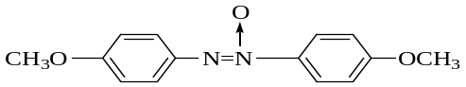

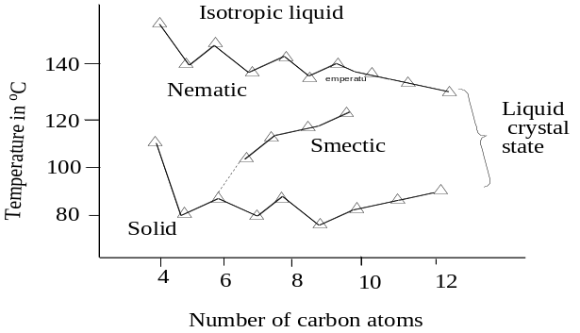
Figure 9: Phase transaction temperature against the number of C-atoms in PAA

From the Figure, the phase transition of PAA is given by
- When the group (side chain) contains 1-5 C-atoms, the transition is form solid to nematic, nematic to isotropic liquid.
- Homologous containing 6- 10 C-atoms shows a transition from solid to smectic, smectic to nematic before melting to a liquid.
- When the number of C-atoms is greater than 10, shows a transition from solid to smectic, smectic to liquid.

Liquid crystalline behavior in MBBA homologous
P-methoxy benzilidene, P-n-butyl aniline (MBBA) is an example for low transition temperature. Molecule with low transition temperature has extensive application in liquid crystal display (LCD).
It may be noted that there is direct linking of alkyl chain to benzene ring on one side chain (C₄H₉),
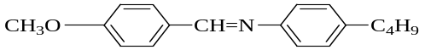

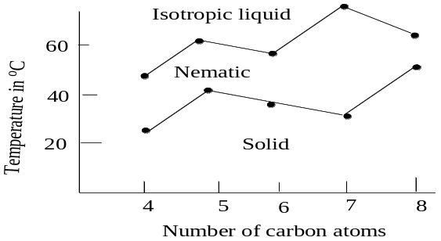
Figure 10: Phase transition temperature against the number of C-atoms in MBBA
whereas the other alkyl (CH₃) is linked through oxygen to the benzene ring. The transition temperature and various phases of first five homologues of MBBA are obtained by the changing length of the chain that does not contain oxygen.
From the Figure the phase transition of MBBA is given by
- When the group (side chain) contains 1-3 C-atoms, the transition is form solid to nematic, nematic to isotropic liquid.
- Homologs containing 4 & 5 C-atoms shows a transition from solid to smectic, smectic to nematic before melting to a liquid.
- When the number of C-atoms is greater than 5 C-atoms shows a transition from solid to smectic, smectic to liquid.

Q- Explain Electro-optic effect in liquid crystals or explain the effect of electricity and light on nematic and chiral liquid crystals.
Effect of electric field:The director in a liquid crystal is free to point in any direction but when a thin film of liquid crystal is placed between two glass plates, the director is forced to point in a particular direction. For example when a thin film of liquid crystal is placed between specially treated glass plate (such as rubbing with a velvet cloth) the molecule close to the glass surface are forced or orient themselves parallel to the surface of the glass plate. In the absence of the electric field, the director at other layers is also aligned parallel to the surface giving a homologous texture. But when the electric field is applied perpendicular to the glass surface, molecules near the surface are aligned parallel to the surface and the molecule at the center of the crystal undergoes deformity. This deformity is important in the operation of the liquid crystal displays because the deformity brings about a significant change in optical characteristics.
Light passes through nematic liquid crystal, when no electric current is passed (no deformity) then the cell looks bright. Light is scattered when molecules are disordered or deformity (in presence of electric-field) and cell appears opaque or black.

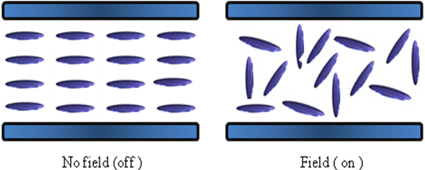

Figure 11 : Electrooptic effect in Nematic liquid crystals.
Effect of light on chiral liquid crystals: When light is incident on two crossed polarizers, no light emerges because the light emerging from the first polarizer is completely absorbed by the second polarizer and hence appears dark.
When a thin film of chiral liquid crystal is placed between two crossed polarizers, in absence of electric filed the pith in chiral liquid crystal acts like a wave and gradually rotates the plane polarization of light by 90⁰. Hence a linearly polarized light incident on the cell emerges as bright light. The 90⁰ twist in the cell is lost when the sufficiently strong electric-field is applied to the till it looks dark. The following conditions are necessary to show electro optic effect in the chiral liquid crystals.
- The plane polarization of the light should be parallel to the surface of the first polarizer
The product of the optical anisotropy ‘∆n’ (the difference in the refractive indices parallel and perpendicular to the director) and pitch ‘p’ should be greater than the wavelength of the incident light.

4-6 μm
BRIGHT

Light
Liquid crystal
3 v
DARK
Light

Figure 12: Electrooptic effect in chiral liquid crystals.

Q-Discuss various applications of liquid crystals. Or Explain the display mechnism in liquid crystals. Or Explain the electro-optic effect of liquid crystals. How is it utilized in display systems

1. Display systems
This is used in information display systems, where liquid crystals control the brightness or darkness of parts of a display device. Numbers can be created in numeric displays which have seven segments (also called pixels). Alphabets can be displayed on a fourteen segment arrangement.
A numeric display consists of seven segments for each digit. Each segment is a liquid crystal. Light emitted by each crystal can be independently controlled so that any digit can be displayed. When an electric field is applied to a segment, the liquid crystal is deformed and when polarized light is incident, it gets brightened. By using dichroic dyes, the contrast between bright and dark areas can be enhanced and required colours can be obtained.
One of the most important effects of electroptic effect (of nematic and chiral liquid crystals) is in liquid display systems (LCD). Electro-optic effect of liquid crystal controls brightness and darkness of emergent light.
LCD requires a very small current. Most of the display in LCD watches and calculators composes of 7 segments. Each seven segments section can display one number. The 14- segments LCD are used of alphabets. Light from the area of each segment are controlled independently and creation of any digits or alphabets is possible. 5x7 matrix segments are used for numbers, letters and figures.
A 7-segment display (Figure 14) consists of seven segments for each digit (each segment represents a liquid crystal). Light from the area of each of the seven segments or pixels is controlled independently and creation of any of the ten digits becomes possible. When an electric field is applied to a segment, the liquid crystal in that segment undergoes deformation (is activated) and when polarized light is incident, the segment gets brightened. A typical liquid crystal display cell (reflection mode) and the electrical circuit with four rows and two columns for a digit to appear is shown in below Figures.
Transparent electrodes Glass plates
Liquid Reflector
crystal
Seal

Figure 13 : Representation of a liquid crystal display (reflection mode pixel) where the liquid crystal is embedded between two glass plates

In the Figure 14, when voltage applied to
i) Row 1 column I activate the liquid crystal in an area a which gets brightened.
ii) Row 2 column I activates the liquid crystal in an area d which gets brightened.
iii) Row 3 column I activates the liquid crystal in an area e which gets brightened.
iv) Row 1 column II activates the liquid crystal in an area b which gets brightened.
v) Row 2 column II activates the liquid crystal in an area c which gets brightened.
vi) Row 3 column II activates the liquid crystal in an area f which gets brightened.
vii) Row 4 column II activates the liquid crystal in an area g which gets brightened.

(b)
(a)
Row 4
Row 3
Row 2
Row 1
Column I
Column II
a
c
b
d
e
f
g

Figure 14: Seven segment LCD for a digit; each row is connected to two segments and each column is connected to three or four segments; a, to g are the LCD cells. (b) display of number 139
For example, to get a number 139 on the display (Fig.b) an electric field is applied between row 2 and column II (operation v) and between row 3 column II (operation vi) to give ‘1’
In the second digit operations (i), (v), (vi) and (vii) give ‘3’
In the third digit operations (i), (ii), (iv), (v), (vi) and (vii) give ‘9’. Thus the digits 139 appears on the display.
To enhance the difference in the brightness between dark (turned OFF, voltage removed) and bright areas (turned ON, voltage applied), dyes are used. Dyes used in liquid crystal displays are called dichroic dyes and give desired colours to the displays with a good contrast.
Various electric equipments use LCD’s :
- Calculators, watches, mobile, telephones, laptops.
- Indicators used in traffic signals, advertisement boards, petrol pump indicators etc.
- In analytical instruments like pH-meter, conductometer, colorimeter, potentiometer etc.
2. Thermography: It is a technique of determining the temperature by using colours developed by liquid crystals. In a cholesteric chiral nematic crystal, the director moves along a helix. When light is incident parallel to the axis of the helix, radiation is divided into two beams. One of the beams is reflected and the other beam is transmitted. If the wavelength is in the visible range, then the reflection produces bright colours. The pitch of the liquid crystal depends upon the temperature, so that the colour of reflected light depends upon the temperature. This property has applications in thermography.
(a) Medical thermography: The portion of the skin above veins and arteries are at a slightly higher temperature than other parts. Using colour changes of liquid crystals, it is possible to trace the path of veins and arteries so that any blockages can be detected. Also the presence of any tumours and their size can be detected.
- Electronics industry: Failure often at some points in electronic components due to local heating. Such locations can be detected colour changes of liquid crystals.
(c) Aerodynamics: High velocity winds are blown over air craft models when pressure gradients develop at various points. This leads to temperature changes which can be detected by colour changes of liquid crystals.
(d) Radiation testing: Some instruments convert radiant energy into heat energy, which is then measured on a device called as a transducer. By coating the transducer with liquid crystals, the radiation can be directly measured by colour changes.
3. Detection of air pollutants : It has been observed that the colour of liquid crystals changes in the presence of impurities. When impurities diffuse into the cholesteric liquid crystal film, the pitch is altered and hence the colour changes. This property is used in the detection of contaminants in the atmosphere.

Question Bank

- What are liquid crystals? How are they classified? Give examples.
- What is a director in liquid crystal terminology? Explain its significance
- Distinguish between thermotropic and lyotropic liquid crystals
4. Distinguish between nematic discotic and smectic discotic phases
5. Explain the molecular ordering in the following liquid crystal phases
(a) Nematic phase (b) Chiral mesophase (c) Smectic phase
6. Explain the liquid crystalline behavior in the following homologous series
  - PAA series, (b) MBBA series
7. Explain the electro-optic effect of liquid crystals. How is it utilized in display systems?

